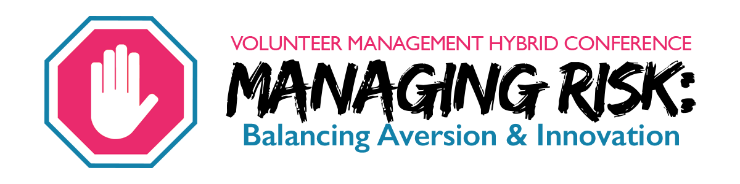
‘Managing Risk: Balancing Aversion and Innovation’ is the volunteer management conference presented by AL!VE, Better Impact, and VMPC (Volunteer Management Professionals of Canada). Now in its sixth year, this year’s topic will explore how balancing aversion and innovation to risk impacts our volunteers, programs and agencies, now and in the near and far futures. Our current streaming event will consist of four 20-minute presentations, followed by a moderated discussion with the other presenters (think Ted talk meets late night tv), including responding to questions from the audience.

https://www.betterimpact.tv/vmhc2020/

Date: Wednesday October 21, 2020
Time: 9:30 a.m. - 3:30 p.m.
Place: Virtual (more details to follow)
Cost: $20.00 for BRAVA members
$25.00 for Non-Members

Name: _____________________________________ Phone: _____________________________
Agency: ____________________________________ Email: ______________________________

Pre-registration and payment required by October 7, 2020
Payment by cheque payable to: BRAVA c/o John Noble Home, 97 Mt. Pleasant St. Brantford, ON N3T 2M2
For more information please contact Beth Pearson at 1-519-751-0466 or via email volunteerdalhousie@execulink.com

